**COMPONENTS OF PROJECT:**

**1 Arduino UNO**

Arduino UNO is a microcontroller board based on the ATmega328P, as shown in figure 1. It has 14 digital input/output pins (of which 6 can be used as PWM outputs), 6 analog inputs, a 16 MHz ceramic resonator, a USB connection, a power jack, an ICSP header and a reset button.

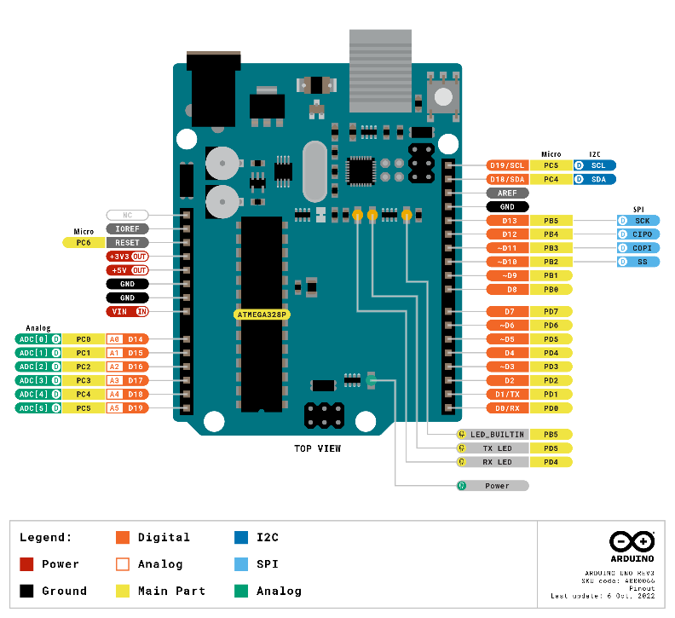

Fig 1

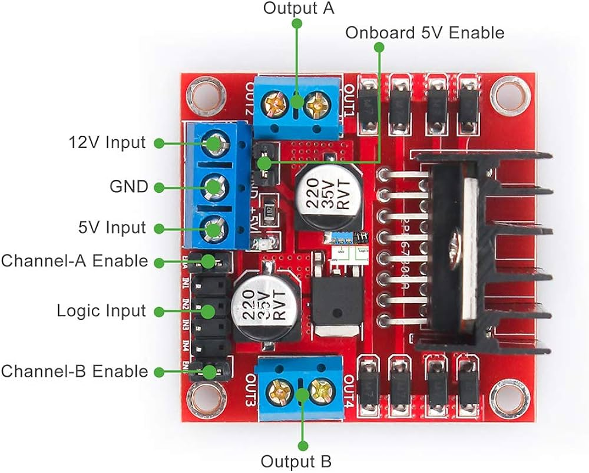

1. **L298 motor driver:**

The L298 motor driver is a popular dual H-bridge motor driver integrated circuit (IC) as shown in figure 2, commonly used in projects requiring motor control:

* Dual H-Bridge
* Maximum Voltage: up to 46V
* Current Handling: The L298 can handle peak currents of up to 2A per channel and 4A if a heat sink is used.

Enable Pins: Each H-bridge has an enable pin that allows for PWM (pulse-width modulation) control of motor speed.

Fig 2

1. 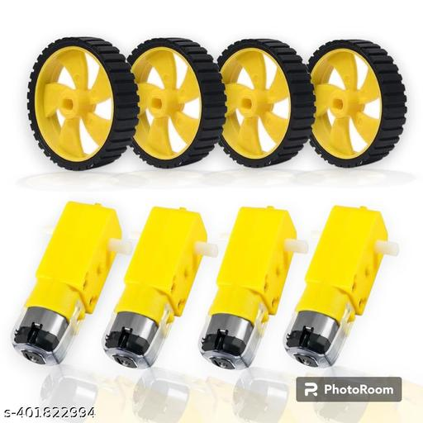**DC Motors:**

Fig 3

A DC motor is an electrical device that converts electrical energy into mechanical motion. It operates on direct current (DC) power and is used in autonomous vehicles, for functions like propulsion and steering. These motors enable the car to move, accelerate, decelerate, and navigate autonomously, playing a key role in the vehicle's overall functionality and movement capabilities. Powered by 3-12 volts, draws an average of 190 mA of current (max 250 mA), as shown in figure 3.

1. **MPU6050:**

The MPU-6050 is a Motion Tracking Device that combines a 3-axis gyroscope and a 3-axis accelerometer in a single chip. It is commonly used in various electronic applications for measuring motion and orientation, as shown in figure 4. Here are the specifications of the MPU-6050:

* 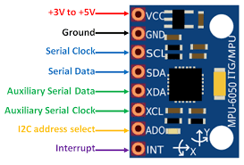Operating voltage: 2.375V to 3.46V.
* Gyroscope:

1. Angular Velocity: Measures rotational motion in degrees per second (dps).
2. Sensitivity: The sensitivity can be configured based on the selected range (e.g., ±250, ±500, ±1000, or ±2000 dps).

* Temperature Sensor: The MPU-6050 has an integrated temperature sensor that measures the device's temperature.

Fig 4

* Accelerometer:

1. Acceleration: Measures linear acceleration in three axes (X, Y, Z).

1. Sensitivity: The sensitivity can be configured based on the selected range (e.g., ±2g, ±4g, ±8g, or ±16g).

* The Digital Low Pass Filter can be configured to filter out high-frequency noise from sensor data.

1. **ESP8266:**

The ESP8266 is a low-cost, highly integrated Wi-Fi microcontroller chip designed by Espressif Systems. It's widely used in IoT (Internet of Things) projects due to its ease of use, low power consumption, and robust wireless connectivity, as shown in figure 5. Below are the key details about the ESP8266:

* 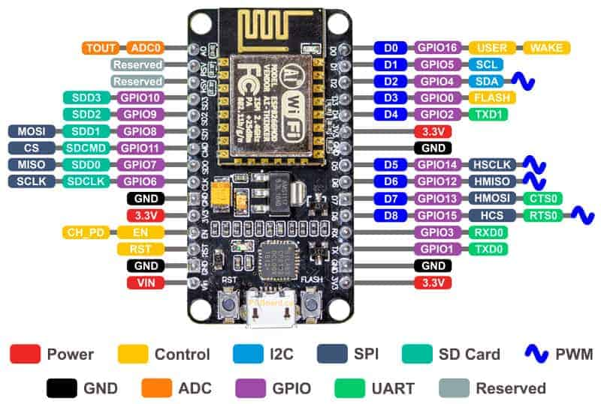Memory:

1. RAM: 160 KB of on-chip SRAM.
2. ROM: 32 KB boot ROM.
3. Flash: The chip supports external QSPI flash memory.

* Power:
* Operating Voltage: 3.0V to 3.6V.
* Power Consumption: Low power consumption with sleep modes.
* Programming Languages: Typically programmed in C/C++.

Fig 5